CURRICULUM – VITAE
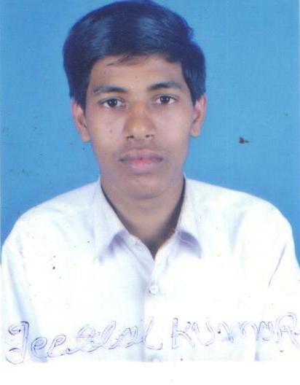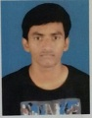
[Your Name]
Permanent Address :-
Vill –……………………
P.O – ………………, P.S – …………………
Dist – ………………… State:- ……………… Pin Code :- ………..
Mob. No. – +91-

CAREERS OBJECTIVES :-
- Willing to work under a challenging and professional environment where I can learn and deliver my best for the dynamic growth of the organization as well as my career.
EDUCATION DETAILS:-
Name of Exam | Board/University | Total Mark | Obtained Mark | Passing Years | Stream | Percentage
MATRIC | H.V.D. JHARKHAND | 800 | 379 | 2002 | ------- | 47.37%
PERSONAL DETAILS:-
Father’s Name -
Mother’s Name -
Date of Birth -
Marital Status -
Sex -
Nationality - Indian
Language known - Hindi & English
Religion -

EXPERIENCE DETAILS:-
1. Sahara India Parivar From 2003To 2010
2. LIC Of India From 2011 To 2014
3. Bharat Gas From 2014 To 2017

DECLARATION

I (Your Name) do hereby declare that all the above information are true to my knowledge and my candidature is to be rejected in my any part of my information is false in incomplete.

Date :- ……………….
Signature

