CURRICULUM – VITAE
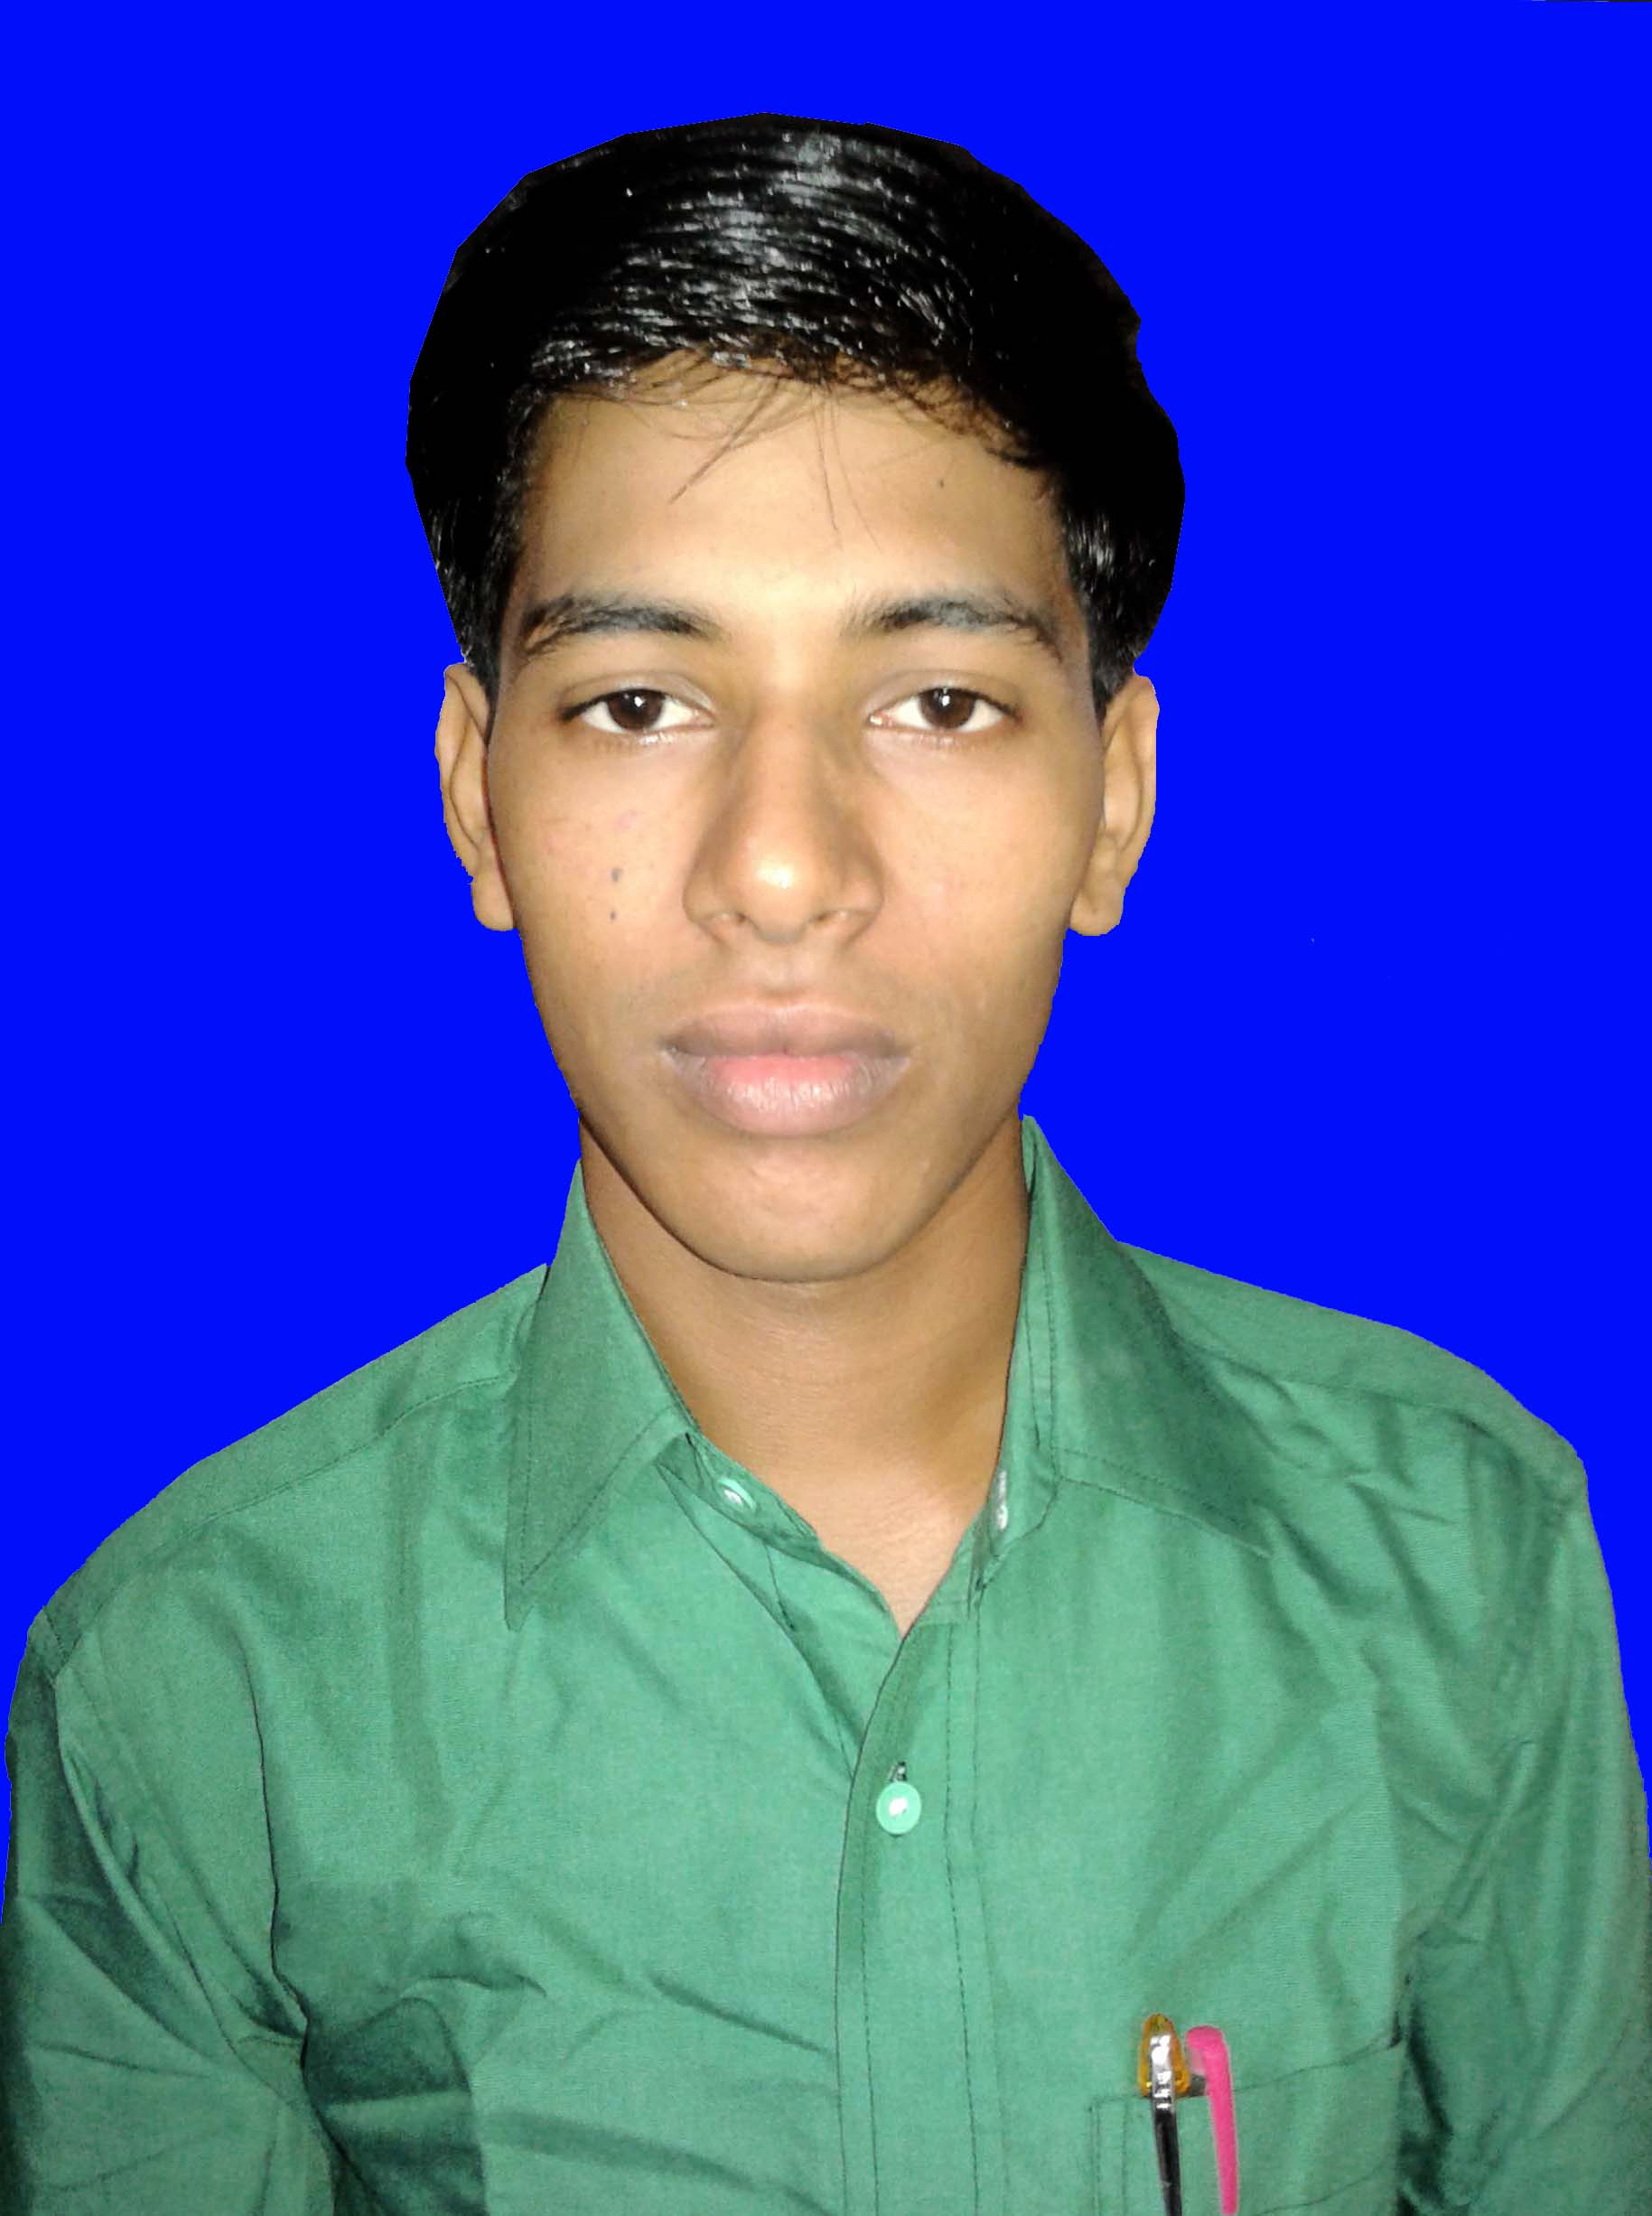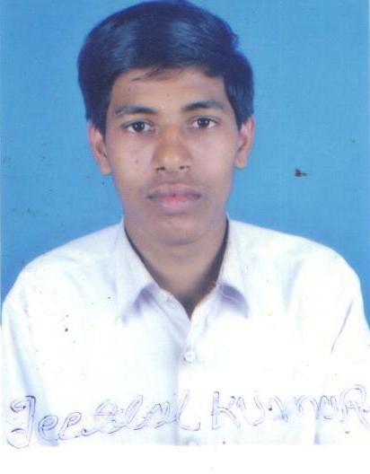
[Your Name]
Permanent Address :-
Vill –…………………………….
P.O –……………………., P.S – ………………….
Dist – ……………………. (BIHAR) Pin Code :- ………….
Mob. No. – +91-
APPLIED POST:- “PLUMBER”

CAREERS OBJECTIVES :-
- Willing to work under a challenging and professional environment where I can learn and deliver my best for the dynamic growth of the organization as well as my career.

EDUCATION DETAILS:-

PERSONAL DETAILS:-
Father’s Name -
Mother’s Name -
Date of Birth -
Marital Status -
Sex -
Nationality -
Language known - Hindi & English
Religion -
PASSPORT DETAILS:-
PLACE OF ISSUE | DATE OF ISSUE | DATE OF EXPIRY | PASSPORT NO.
Experience:-
1.I am working as a Plumber in Blue Star Limited New Delhi sing 15 Feb 2014 to 30 Jul 2015.
2.I am working as a Plumber in L.N.T. Delhi sing 10 Sep 2015 to 15Jan 2017.

DECLARATION

I (Your Name) do hereby declare that all the above information are true to my knowledge and my candidature is to be rejected in my any part of my information is false in incomplete.

Date :- ……………….
Signature

